GET/products: Fetch a list of products from MongoDB.
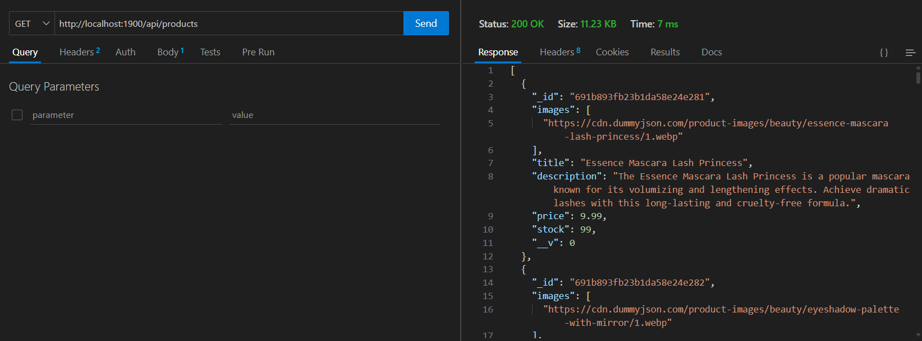

GET/products/ : Fetch details of a single product by its ID.

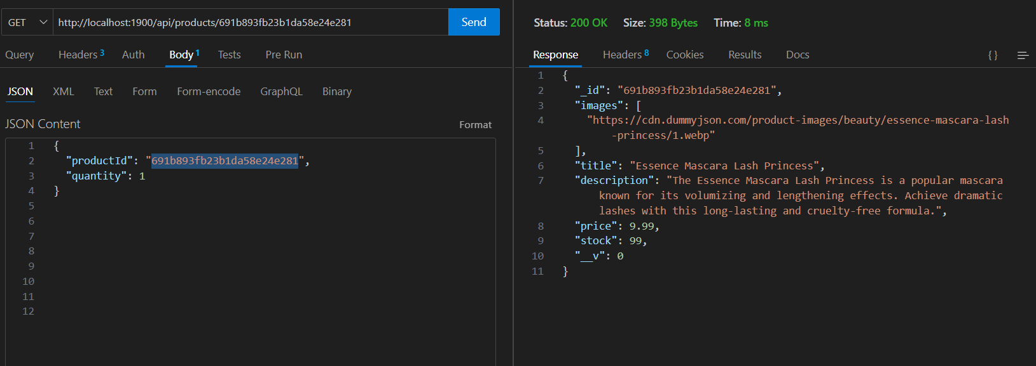
POST/cart: Add a product to the shopping cart.

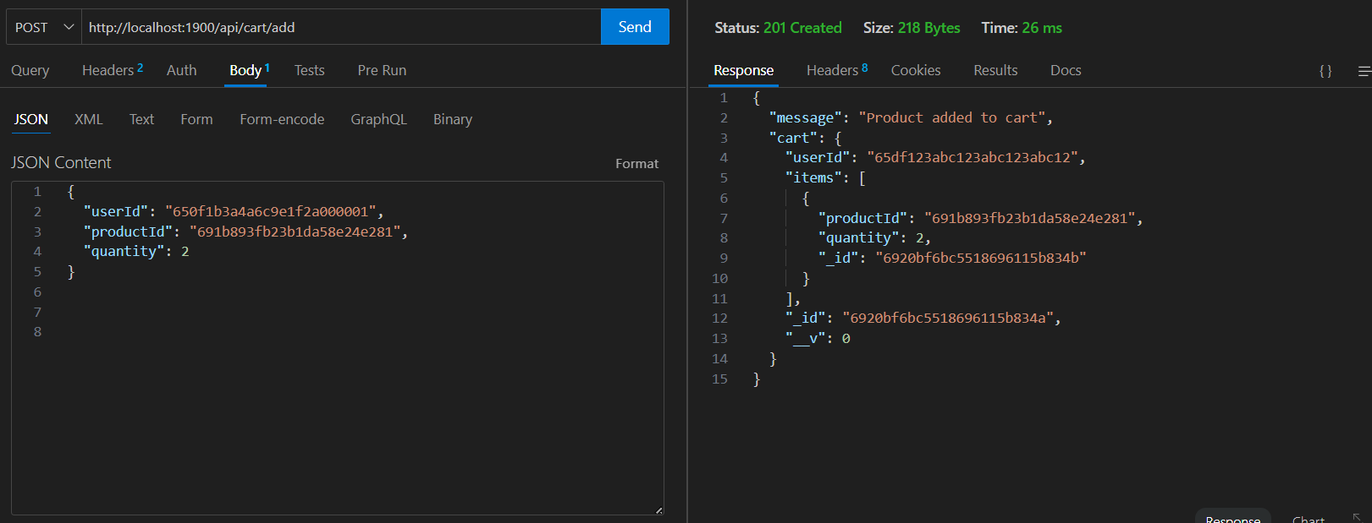

PUT/cart/ : Update the quantity of a product in the cart.
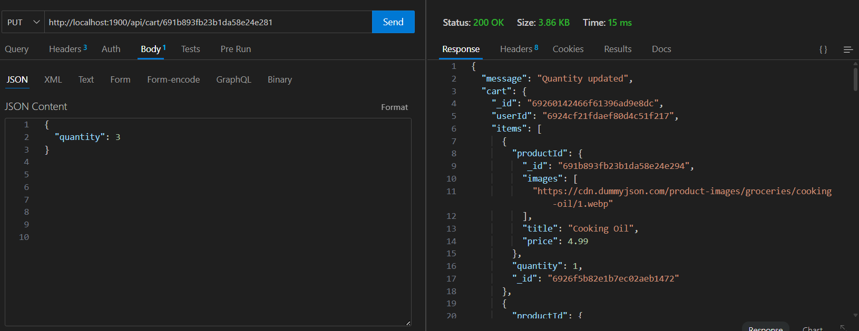

POST/register: Register a new user.
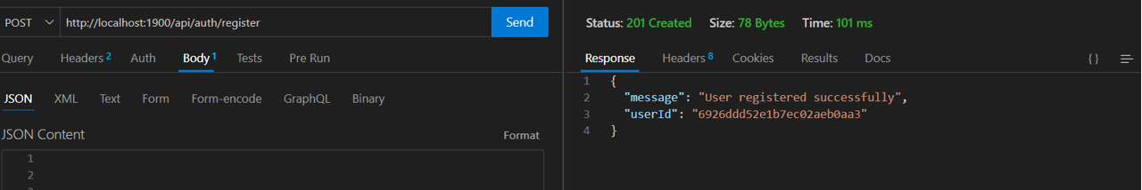

POST/login: Authenticate user and return a JWT token.
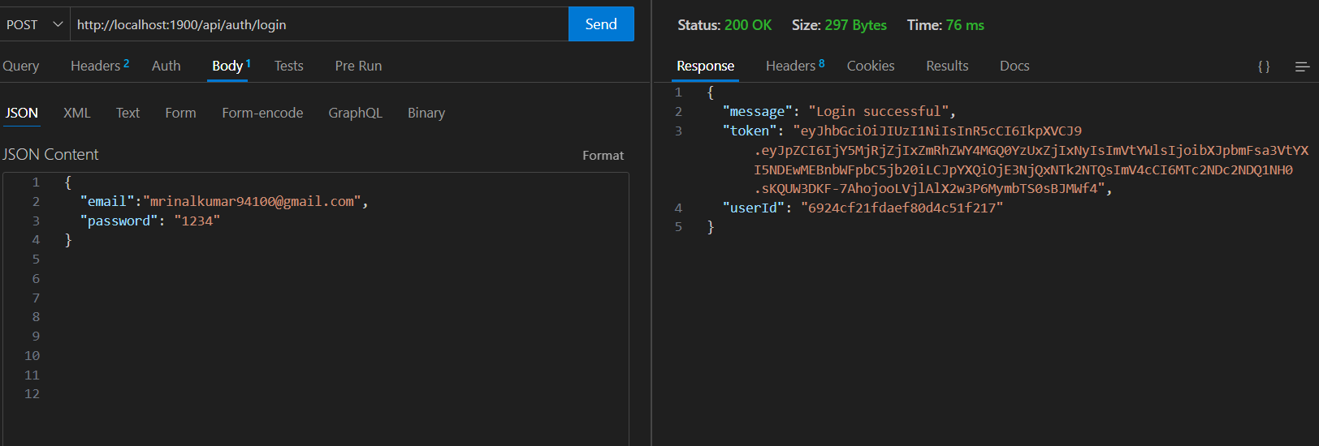

Products: Each product should have fields like name, price, description, and stock quantity.
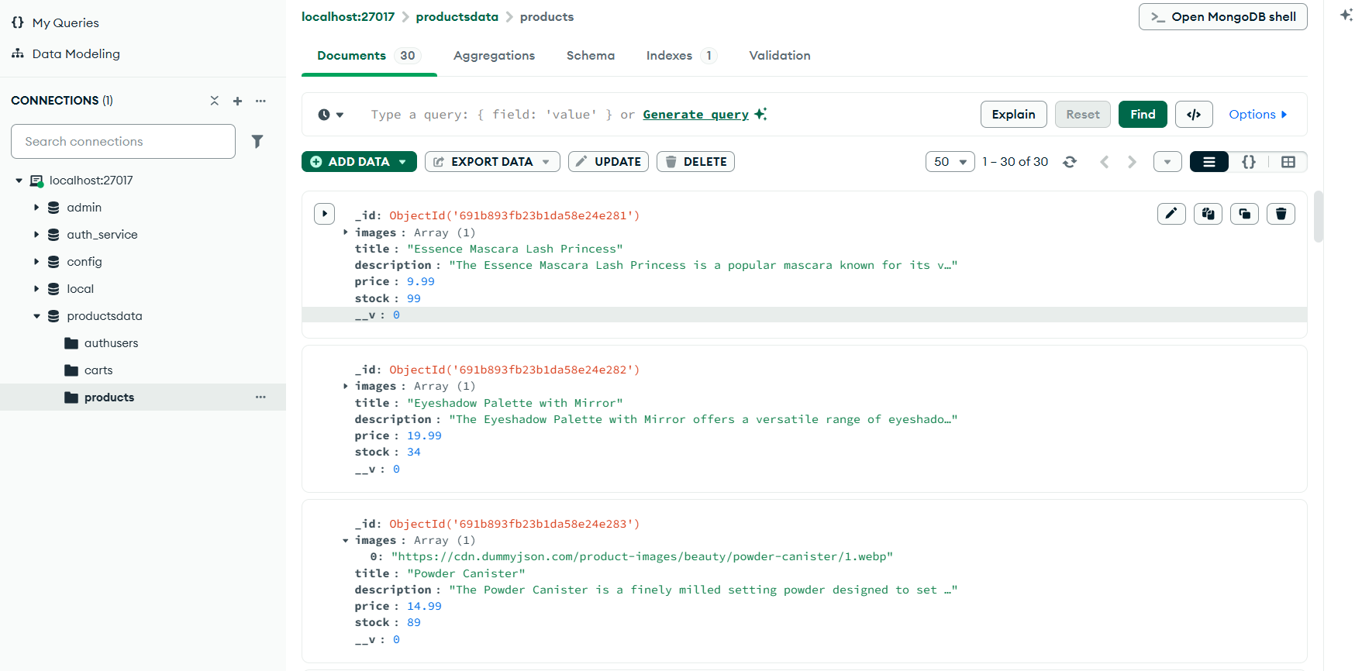

Cart: Store items added to the cart, including product IDs and quantities.
